Use Mozilla Firefox only

1. Go to Process Definition

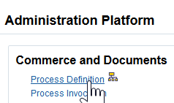

1. Go to Text Library Templates and click on List

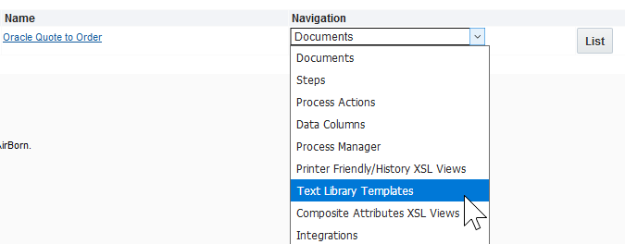

1. This will open Rich Text Editor and then in Shared Templated Folder click on BAE Systems V3

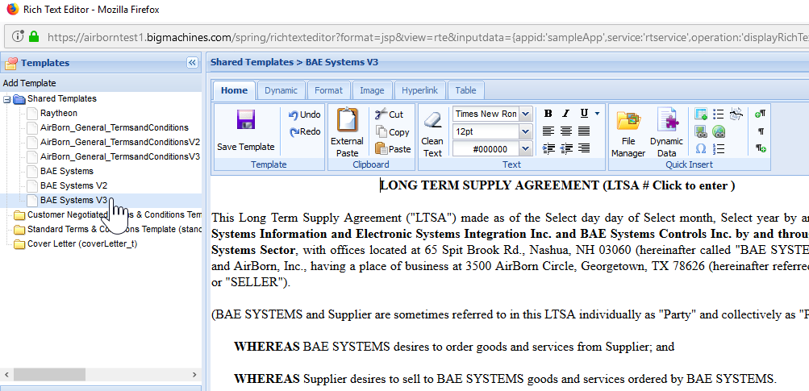

1. Start adding data as per attached word document
2. Put the cursor where you want to add data as shown below

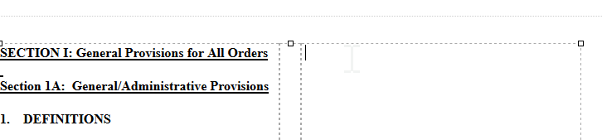

1. Click on External Paste when copying from the attached word document

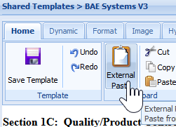

1. Paste the content in pop-up window

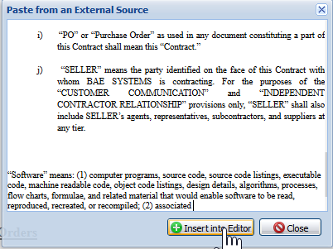

1. Once you add some data, deploy it and test to ensure error does not come up. Follow the steps below to deploy

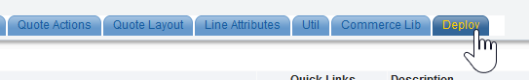

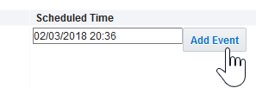

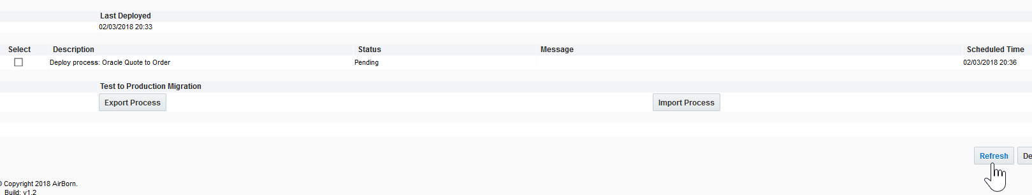

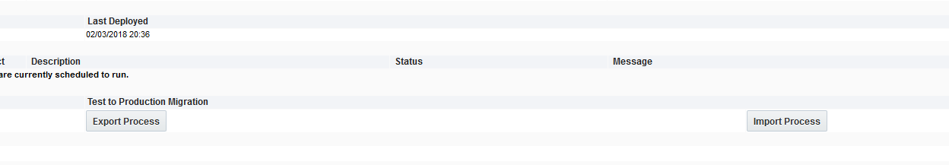

1. To Test create a quote always create new quote and follow screenshots below to test.

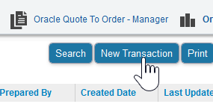

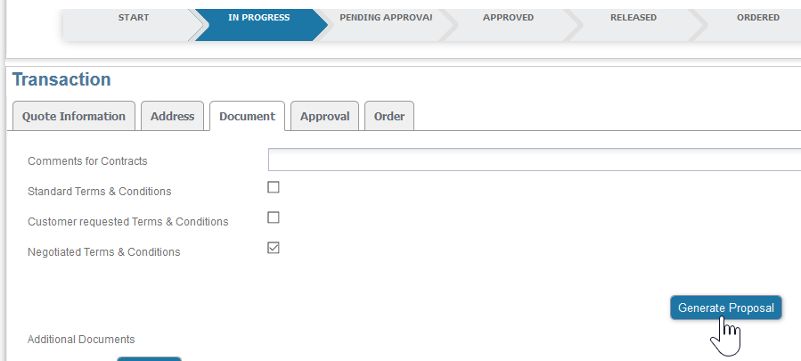

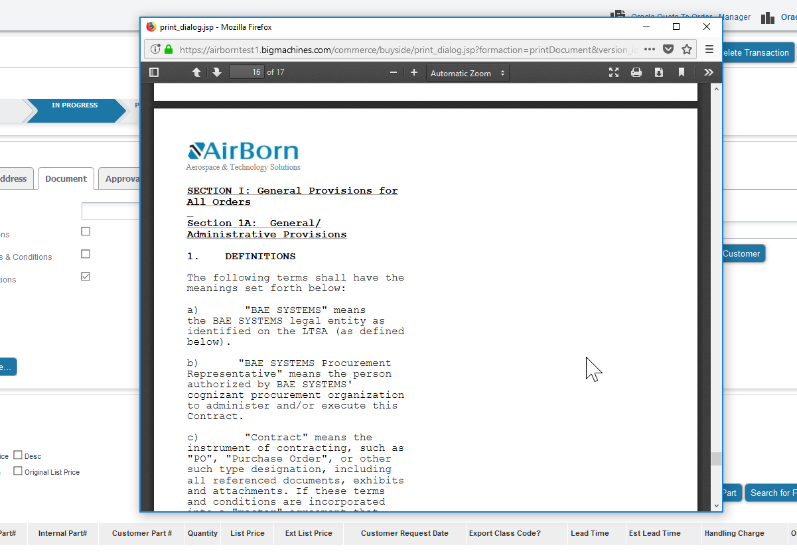

1. If the PDF document does not come up and instead an error comes like below

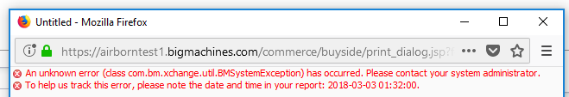

1. Then go back to the rich editor and delete whatever changes were made and re-deploy to test whether the error now goes away. If it goes away, then continue adding data
2. If the error does not go away then create a new Shared Template and follow the steps below to associate this new template with the attribute

